Wise Words
Gary Wise
This is a very sad time for me. The Dojo has stopped updating. The first Magic article I ever wrote was a tourney report about a Mirage Block Constructed qualifier in which I played an ErtaiTog deck designed by Mike Donais. I wrote it for a number of reasons, among them being the fact I'd won and it was something worth writing about, the fact that tourney reports were becoming more and more popular, and most importantly, the fact that I knew there was a strong forum where said article would be seen.

The Dojo was a very important part of my development as a writer. Before I started writing about Magic, I was barely capable of writing a thousand word essay. Now, five years later, I'm that guy who writes the longest tourney reports in the game. Once I'd started learning something about expressing myself on paper (or screen), I became one of the first 'paid' writers for the Dojo, receiving a box for each article I wrote. In retrospect, I fear I may have helped start the trend that brought the Dojo to its knees.
At PT - NY 3, Jon Finkel's first PT win, speculation was rampant that New Wave was "going after the Dojo." Up until that time, the Dojo was a free forum for writers and readers. Run by the Sensei, Frank Kusimoto who was balancing the site, a marriage and a full time job, the Dojo had unofficially become the official place for 'playas' to go for their info. Writers ranged from Randy Buehler to what was then known as Team Dickhead to the Deadguys. The Dojo was everything that was good in the Magic community.
Unfortunately for Frank, with New Wave's decision to get into the web game came payment for writers. Team CMU was lured away from the Dojo's ranks with others soon to follow. That's why I approached Frank about writing for the site on a more official level. I was loyal to the Dojo and didn't have much of a following, so if Frank had turned down my request for a box per PT report, I probably would have kept writing for him anyways, but Frank's downfall as a businessman may have been that he was fair. His reply was to offer me a box a month instead so that I'd be inspired to write more often. It was my first paid job as a writer. Eventually, it appears the payments got too much for a little website created out of love for the game.
That's why I find this column to be so ironic. Not only did I get my start on the Dojo, but also used my short-lived column to springboard myself into working for the Sideboard. For those of you who have only recently gotten into the game, you may only know me as the Limited analysis guy, but for you old hands, I'm the brash, outspoken and sometimes obnoxious loudmouth who always tells it the way I see it. I don't ask people to agree with everything I say, only to understand that I'm being as honest with you as I can be and hope that you'll respect that.
Here then is the first installment of my new column, Wise Words. I call it that because I know that I have always had a very strong view of things, and that has to be taken into account when reading a column like this one, which has given me license to avoid objectivity in some cases. This first installment is a special look back at the year 2000 and the goings on in the game. Enjoy.
...And God said 'let there be light!'

The earliest memories of the year 2000 have to be associated with a lack of expected darkness. For months we'd been prepared by the experts for the end of civilization, a Fight Club-esque event that would see society reset itself with the destruction of credit card companies and computers everywhere. Turns out the experts were wrong and life went on as normal, unless you were an avid fan of a game called Magic: the Gathering.
2000 was a year of fears, growth and money for Magic players. From the early announcement trumpeting the creation of the Masters series to the scariest moment in the games recent timeline, the Hasbro cutbacks, we've seen WotC through some ups and downs.
Here then is a month-by-month look at how the Magic calendar evolved.

January
Ironically, from the Sideboard's point of view, the year started with a look at the past. On the third day of the year, our first article, Days Gone By, a look at the first ever tournament, played at GenCon '93, was posted. The tourney, whose final is described play by play, is eventually won by a long lost gamer named Alex Parrish (Alex, if you're reading, write us a tourney report!). Makes one long for simpler times. A day later, as if to purge those longings, the announcement was made that those players who had been inactive for a year would find their records purged from the DCI database. I'd rather be in the now.
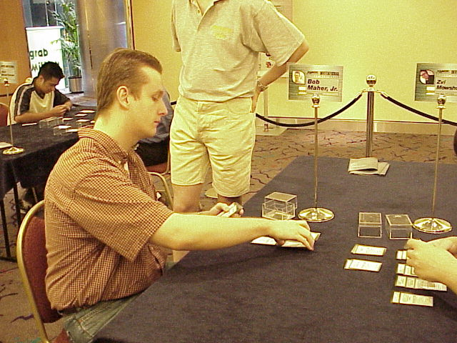
1999 had ended with Bob Maher's big breakthrough, but that only offered us a glimpse of things to come. Bob started the year where he left off, winning GP Seattle with his vaunted Oath deck, making him the first player in the game's history to win two consecutive premiere level events in a row. That he did it with the same deck makes the feat all the more remarkable. Maher's finals opponent, Jeremy Brower, presumably impressed by Maher's success in Chicago, also chose to play Oath. Maher won the final by getting Jeremy into a Wasteland Recursion lock.
Two weeks later, the months only other major tournament, Grand Prix - Madrid was held. In a field of 329, only one American, Alex Shvartsman, made the trip, but he represented his country well, finishing in 3rd place. The tourney was won by local Carlos Barrado playing Michelle Bush's creation, Trix, which would go on to dominate the format. Barrado defeated countryman Xavi Gonales in the final. The importance of this Grand Prix from a historical perspective would be paramount, with it being Trix' first major win. A year later in Amsterdam, a record 30 North Americans would compete, as strong an indicator of the effect the Masters series has had as any.

February
PT - LA was the first and only Pro Tour to focus solely on Masques Block Limited, and it brought a number of surprises. The format apparently turned the gaming world upside down, with most of the game's biggest stars getting knocked out on Day 1. Things went badly enough that Randy Buehler and Tom Guevin had made a gentleman's bet in which Tight Tommy backed New England's finest while Buehler had his pick of any 8 remaining Pros. Of the eight Buehler selected, including Jon Finkel, Steve OMS, Kai Budde et. al., only one made it to Day 2.
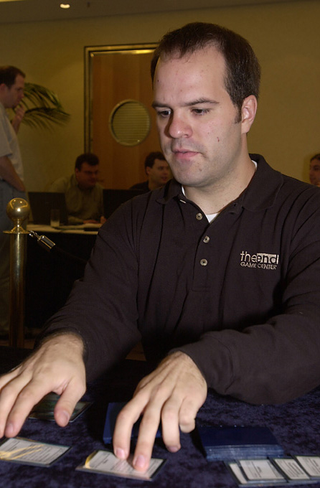
The one however, was one of the biggest stories of the year. After making Top 8 in LA at the beginning of 1999, Mike Long took some time off from the pro scene. Speculation was rampant that Long might be gone for good, but 'the Emperor' decided to make an appearance at PTLA2k and it paid off with the new card store owner. En route, Long did what he does best, stirring up controversy in his final round match against Darwin Kastle. Playing for Top 8, Long, playing a deck with 6 Howling Wolves was accused by a number of onlookers of stacking his deck. The evidence was deemed inconclusive by judges and organizers though.
Long's Top 8 deck looked unstoppable, but a random scrub from Oregon, who turned out to be not so random, was able to stop him in the semis. Chris Benefel, a 17 year old student who had lived within walking distance of the Wizards of the Coast Game Center in Seattle for a time chose LA as his time to emerge, becoming a hero to observers when he beat a mana screwed Long in the fifth and deciding game of their match.
Benefel would go on to a number of second place finishes over the year, with the first one coming at the hands of PTLA champion Trevor Blackwell. Like Long, Blackwell hadn't played on Tour in over a year, but he'd made Top 8 at GP San Diego and seemed to have a solid understanding of the format. Drafting a RW Rebel deck, Blackwell was able to get his searchers down and summon a number of Gliders three times vs. Benefel, resulting in a PT win and a spot on the gravy train. Blackwell would finish 10th at PTNY to solidify his standing as one of the Tour's top players.
GP Taipei saw further evidence of the strength of Trix emerge. Tadayoshi Komiya, a veteran of 8 Pro Tours, who already had one GP (Kyushu) victory to his credit, piloted his Trix deck to victory, defeating countryman Tsuyoshi Fujita's Sliver deck in the final. Alex Shvartsman again made Top 8, this time accompanied by another American, Toby Tamber, who had been living in the area.
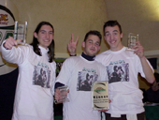
In the heart of the season of Trix came an anomaly. With Underground Seas and Swamps everywhere, Trey Van Cleave, who Randy Buehler describes as one of the strongest metagame deck builders in the world today, won his second Grand Prix (the first was Limited) with Three-Deuce, a fast utility deck with Rancors nullifying Necropotence's... well... potency. In the final, Trey beat Brit Fitch, running Sligh, in three straight games, thanks in part to his sideboarded Sanctimonys.
GP Cannes proves to be the world's introduction to one of the finest teams in the game. With a number of PT players making the trip to form makeshift teams, to the surprise of anyone not in the French teams league, a team called Black Ops emerges victorious, beating Alex Shvartsman and Team New Wave. The Frenchmen, brothers Antoine and Olivier Ruel and Fleurent Jeudon, would later go on to win the Teams challenge in NY and have a strong showing in the Teams PT.

March
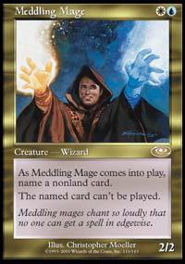
With no PT's on the immediate horizon, the Tour's finest gathered in Kuala Lumpur to compete for the right to call themselves 'Invitational Champion' and design a card of their choosing. In the end, it was Chris Pikula, with help from Dave Humphreys, defeating teammate Jon Finkel in the finals. Pikula's victory did not come without a price, as in exchange for deck tech from 'the Hump,' he had to promise that he'd fly the YMG star to the next Invitational if he didn't get the invite. As a result, later in the year, Humphreys would get a free trip to Sydney.
That same weekend, GP Kuala Lumpur ran simultaneous to the Invitational. Bob Maher, fresh off victories at PT Chicago and GP Seattle made an appearance, but couldn't make a dent in the Malaysian tournament scene, finishing a disappointing 30th. In the end, it was Ryan Siong Huat Soh, playing Trix, who walked away with the victory.

April
With the beginning of spring, April brought with it a new PTQ season. GP Frankfurt, with an amazing 194 teams attending, was the first major event of the year to use the new Team Rochester format. In the end, Germany's III Heroes (Jim Herold, Moises Sebastian and Gunnar Refsdal) emerged unscathed, beating the Czech team, Hammer of Brno. The three best-known teams in the tourney, Black Ops, Juggernaut and Antarctica, all failed to finish in the money.
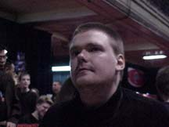
The next weekend brought with it the second PT stop of the year. New York was host to a Pro Tour that saw one deck - Rebels - played by a higher percentage of competitors than any in Pro Tour history. Eight of the Top 16 finishers played either mono or near mono white rebel decks, and more half of the competitors on Day 2 did as well. In the end, however, it was Mogg Squad's Sigurd Eskeland, playing the Waters deck designed by Zvi Mowshowitz and Scott Johns who won the whole thing, defeating Warren Marsh in the final. Eskeland, who'd had a sub-par year up to this point, had planned on retiring from the PT after the event.
During this same weekend, the first 'Challenge' tourney was held. A harbinger to the creation of the Masters series, this tourney saw four of the world's best teams, Antarctica, Black Ops, Games Empire and YMG, compete in a four team tourney for their share of $30,000 in front of ESPN2's cameras. In a grueling match that went the limit, Fleurent Jeudon of Black Ops was able to defeat Dan O'Mahoney-Schwartz to win the tourney for the French.
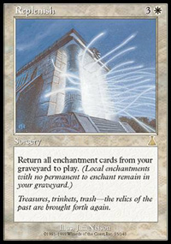
Alex Shvartsman's dominance of overseas GPs continued later in the month with his trip to Nagoya. Now in the player of the year race, Shvartsman, along with fellow PotY candidate Trevor Blackwell and Singapore's Nick Wong won the Japanese GP with a 2-0 victory over Masato Club (Natsuo Goro, Jun Nobushita and Tadayoshi Komiya) in the finals. The biggest surprise of the tourney had to be Mike Long's appearance alongside Dave Williams and Bob Maher on team Godzilla, but the American triumvirate, while undefeated after 10 rounds, were unable to get by Masato Club in the semis.
Finally, at the end of an exhaustive month, US Regionals were held across the country on the 29th. This was significant because of the effect these tourneys have traditionally had on the shaping of Nationals metagames, and this year was no different. Trinity, Replenish and Stompy all saw a measure of success, while Ped Bun's Sexy Rector and Elliot Fung's Rebels carried their respective owners to Regional victories.

May
For the professional Magic player, the highlight of the year had to be the announcement that $2 million was being added to the Pro Tour, Grand Prix and other Magic avenues. With increased prize support, an extra PT and the newly introduced Masters Series, it would now be possible for professional level players to treat the game as more than a mere hobby. The Masters series would feature four 32-person tourneys a year, each with a prize purse of $150000 (the 1 teams Masters series has a purse of $156000), and be televised on ESPN2. It was felt by many that this was the most important step taken in some time towards legitimizing the game for the general public as an intellectual sport, as well as heightening public awareness of Magic's existence.
The only premiere level event of the month was GP St. Louis, the first ever American teams GP. Team Antarctica (Jon Finkel, Dan O'Mahoney-Schwartz and Steve O'Mahoney-Schwartz), felt by many to be the best team on the planet, emerged victorious, defeating archrival YMG (Rob Dougherty, Darwin Kastle, Dave Humphreys) in the semis before defeating the surprising Dogma (Rob Liszka, Mike Heffern, Aaron Estrin) in the final.

June
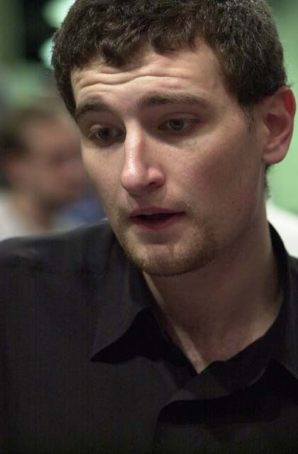US Nationals is a tourney that non-Americans oft-times feel is over-promoted, but there could be no doubt of the importance of this year's result. Now attending University, Jon Finkel had taken a step back from full time play, leading many to question whether he'd been surpassed by Kai Budde, Kyle Rose and the like. The coming of the Masters Series legitimized Magic as a job in Jon's eyes, and upon hearing of its creation he immediately set back to practicing and learning the ins and outs of the present game. Day 1 saw Jon go 6-0 in Masques Block Limited, defeating Waiken Soo in the final match of the day. This was important because a draw in this round would have meant a spot in the US Draft Challenge for Jon and Waiken, but having confidence in his deck and wanting to leave himself in as strong a position as possible going into Day 2, Jon decided he'd play, potentially risking thousands of dollars. With his 4 Withdraws in tow, Jon defeated the Chicago native, securing a spot in the Challenge and on top of the Nationals leader board.
Making top 8 with Mike Flores' mono black deck, Jon defeated all three of his eventual US teammates (Forsythe, Hernandez and Benefel) en route to winning his first National Championship. This would be the beginning of an amazing run that would see Jon dominate throughout the rest of the year.
The only disappointment of Jon's weekend had to be the US Draft Challenge. With Finkel losing in the quarterfinals the competition looked to be wide open, with Trevor Blackwell eventually defeating Darwin Kastle in the final. The story of the competition though was once again Mike Long, who was disqualified from his semifinal match with Blackwell for insufficient randomization of his deck. He would eventually be suspended for a month for his indiscretions.
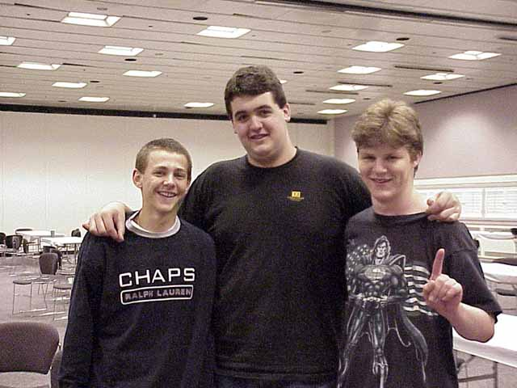
The final GP of the teams season came in Pittsburgh close to the end of the month. With North America's finest all assembled, it was Huey, Ben and Casey (Billy Jensen, Ben Rubin and Casey McCarrel) who emerged victorious with an amazing 17 minute final victory over Dark Side of the Moon (Ray Tautic, Brian Lynch, Ben Halpren). Once again, YMG and Antarctica both made the cutoff, with the two powers each falling in their respective semifinals.
The new PTQ season, Masques Block Limited, started strong with a GP in Copenhagen. In a surprise finish, local Niels Jensen defeated favored American Dan O'Mahoney-Schwartz. This GP provided evidence of the greater American presence on the European tourney scene, with such names as Bob Maher, Brian Hacker and Steve O'Mahoney-Schwartz making the trip.

July
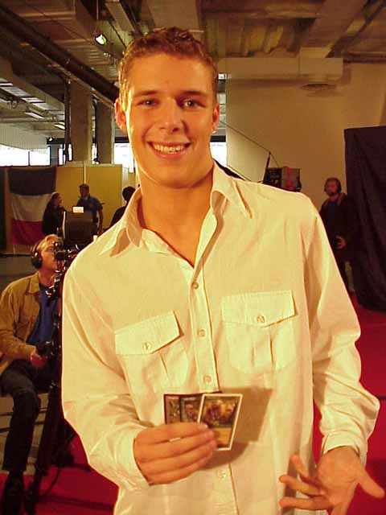
As Regionals is to Nationals, European Championships is to Worlds. No tourney has more impact on the Worlds metagame. Green, Blue and Replenish decks dominated this year's Euros. Less successful Tinker decks provided a skeleton on which the Tinker decks at Worlds would be based. Euro's was seemingly the launching pad for one of the year's breakout stars, Noah Boeken. With a Top 8 finish in Copenhagen, Noah appeared to be on a streak coming into Euro's, but no one could have suspected that the Dutchman would emerge the victor. This would the highlight of a very strong 2000 for Noah, who piloted a very similar Stompy deck to that played by good friend Ryan Fuller at Canadian Championships, a tournament Fuller won.
Elsewhere, Masaya Mori helped the world take a big step towards recognizing the strength of Aaron Forsythe's Son of Hermit deck by winning his second APAC Championship. Amazingly the Japanese player still has not made it to the Magic: the Gathering Invitational. Likewise, Mexico's Gustavo Chapela, also playing a variation of Son of Hermit won the Latin American Championship. It was his playtest partner, Gerardo Godinez, who received the first ever Latin American Invitation to the tourney.

August

World Championships is the premiere event on the Pro Tour calendar, and this year's tournament couldn't have been scripted better. Fresh off his Nationals win, Jon Finkel stormed through the field, with American teammates doing likewise. The US lead after each day including Sunday, which saw them defeat team Canada (Ryan Fuller, Gab Tsang, Murray Evans, Sam Lau) in a clash that was pushed to the maximum 5 matches amidst controversy. In the match that pitted Chris Benefel against Murray Evans, the American made uncharacteristic misplays that had those in crowd yelling foul, but any so-called evidence was deemed circumstantial and the matter was dropped.
Thankfully, Finkel was not to be overshadowed. In addition to his teams win, Jon emerged victorious in the main event, winning his first World Championship. In doing so, Jon became the second player to win 2 PT level events, the first with a PT and a World Championship, the first to win a World Championship in both teams and singles, and first to win both halves of the Worlds crown at the same event.
Finkel's was not the only star to shine throughout the week. Bob Maher, who had won PT Chicago earlier in the season entered the tournament without much hope of winning the player of the Year race, which most felt came down to Darwin Kastle and Alex Shvartsman, but a superlative effort from the Madison, Wisconsin resident left him in second place, with Maher losing to Finkel in a tense 5 game final. Maher defeated Germany's Dominik Hothow in the semis to steal the Player of the Year race from Darwin Kastle, who was seen waving a German flag in the audience during the match. This is the second time Kastle has entered Worlds the PotY race leader only to lose the crown in the year's waning rounds.

September
September, as always brought with it the beginning of another PT season, but this season was sure to be unlike any before it. With the announcement that the Masters would be in full tow starting with New York, the game's top players started taking a more professional, full-time attitude towards the game.
With the Masters combined with extra money in the prize pot (especially in the teams PT, whose purse doubled), the Pro Tour's finest converged on New York's Madison Square Garden ready for an entirely new experience in gaming. Ironic then that many of the PTs finest teams faltered in the first PT of the season. Black Ops, Huey, Ben and Casey and Your Move Games all overcame slow starts to record solid finishes, but Antarctica and Juggernaut both had what had to be considered poor showings. Both Casey McCarrel and Dirk Baberowski arrived late for Day 2, costing both of their teams crucial matches, and forcing Mark Rosewater to reschedule the entire feature match area for that round.
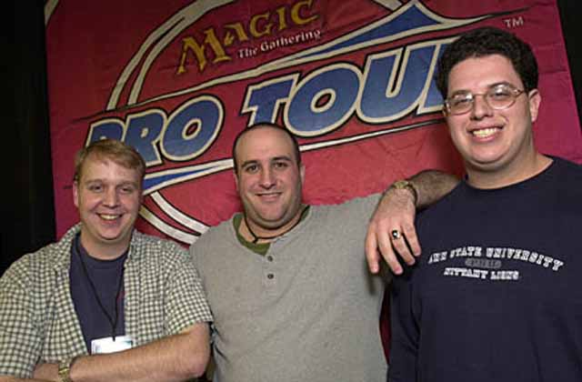
In the end, the biggest beneficiaries of these occurrences had to be Potato Nation (Mike Turian, Scott Johns, Gary Wise). With plenty of PT experience but very little time logged as a unit, the three veterans finished first in the swiss, passing their eventual finals opponents Car Acrobatic Team (Aaron Forsythe, Andrew Johnson, Andrew Cuneo) when the two met head to head in the second-to-last round. CAT's performance continued the obvious streak that Aaron Forsythe was on, following a top 4 finish at US Nats and a teams victory at Worlds. Ironically, with the Potatos not able to practice together, Turian worked with CAT in preparation for the tourney.
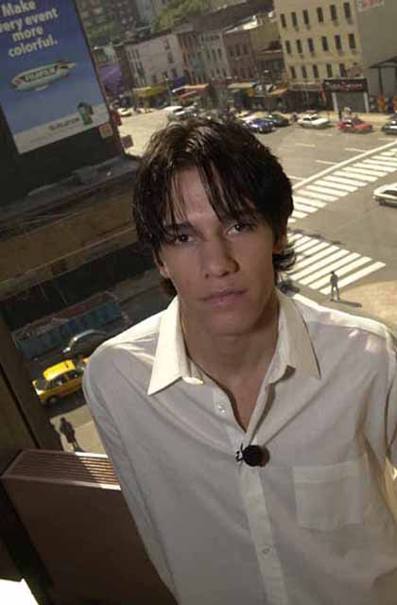
Through the weekend, the first Masters Tourney was played in New York's Neutral Ground. With extended the format of choice, thirty-two of the top players in the world competed, with Billy 'Baby Huey' Jensen emerging victorious with a surprising victory over the story of the tourney, Jason Zila. Two years removed from PT play, Zila had been playing in weekly tournaments near his home in California, and assured of at least $2000, made the trip to NY. What happened then was extraordinary: after defeating recently dethroned player of the year Kai Budde, Zila won an improbable match against Tony Dobson (who, along with Franc Canu qualified through the gateway) when the latter mistakenly cast Impulse on his own turn, untapped and drew despite having the game locked (3 Back to Basics in play vs. all non-basic land). Zila, playing a deck that could have been built when he'd last seen PT play, made it all the way to the final before losing to Jensen.
With Worlds and NY concluded, it was back to business and the PTQ season at hand. With the groundbreaking nature of Worlds and NY being what it was, GP Porto had a lot to live up to, but it did so with flying colors. Antoine and Olivier Ruel, brothers and teammates on Black Ops, had previously accomplished relatively little as single entities, but in Porto they finished 1st and 2nd respectively, becoming the first pair of brothers ever to face one another in the final of a premiere level event. Americans Dave Williams and Mike Pustilnik made Top 8, as did Canadian Ryan Fuller, who by this time was on his way towards joining Alex Shvartsman as international GP travelers.
On that same weekend, one of Japan's brightest stars managed to show why he has been so respected Stateside. Satoshi Nakamura, gravy trainer and Invitationalist, emerged victorious, defeating Takamasa Fukata to conclude an all-Japanese top 8. Nakamura, well known for his unusual hats and Ice Cream shaped erasers/life counters/tokens drafted a strong BR deck in the top 8. He presently ranks 30th in the 2000-2001 PotY race.

October
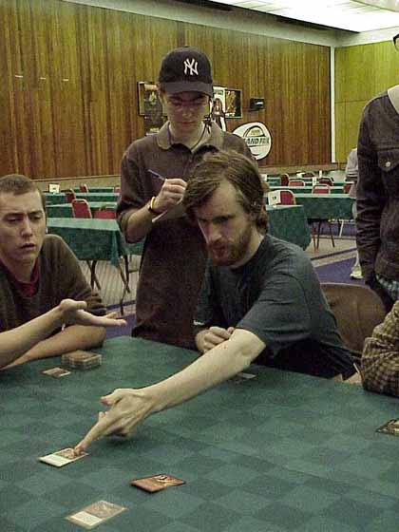
The beginning of October brought with it new cards in an old format. While the PTQ season still insisted upon Rochester draft, with the release of Invasion came a brand new environment. The story of the first major tournament to use Invasion - GP Manchester- had to be John Ormerod. A Top 8 finisher at PT Mainz and 9th place finisher at Chicago 99, Ormerod seemed to be one of the first to understand the strengths of the popular UB strategy in the format, drafting as many Probes and Recoils as he could find. Ormerod, who has been on and off the PT for the last year or so, was running so hot that with three rounds to go, people were recommending he drop from the tournament so he'd qualify for the Masters Series in Chicago based on his rating. Instead, Ormerod played on, finishing the Swiss undefeated, only losing in the final to Darwin Kastle. The GP victory meant a lot to Darwin, who had never won a premiere level event as a soloist. A good start to the year for the PT PotY runner up.
Three weeks later, with the format more firmly established, twin GPs occurred in Helsinki and Dallas. The former saw Noah Boeken continue his hot streak. Fresh off a top 8 finish in Manchester, the Amsterdam native defeated Erno Ekebom of Finland for his second victory of the year. Also making top 8 was Dominik Hothow, who was out to prove his top 8 finish at Worlds was no fluke.
While Helsinki continued a hot streak, Dallas ended a very cold one. Matt Vienneau, considered an up-and-comer four years ago when he made top 8 at PT Atlanta had failed to do so since, becoming better known for his whiny (and entertaining) rants on the Magic Dojo than his PT play. Despite his unfortunate streak, Vienneau persevered, and it finally paid off at GP Dallas, where he defeated Chris Benefel in the final, lending to the theory that Benefel was starting to feel the pressure of not winning 'the big one'.

November
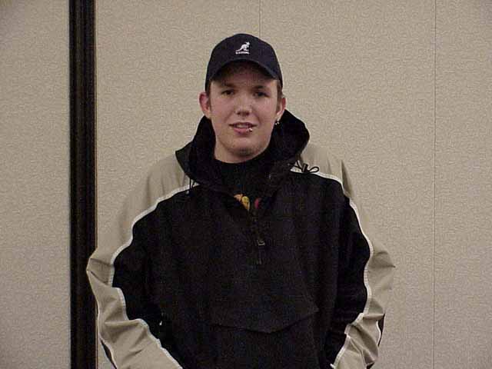Yet another PTQ season began with GP Phoenix. With Americans gathering in Arizona with Extended decks in hand, a number of top players who would normally make the trip missed Phoenix because of the Invitational. The tourney, which many expected would be dominated by Trix, was instead Sliver happy, with three Top 8 finishers, including eventual winner Sean Fitzgerald riding the deck to success. Fitzgerald defeated Sean Smith, playing Oath, in the final.
That same weekend in Kyoto, Japan, Ryan Fuller essentially announced to the world that he was now full time. Fuller, playing Survival amidst a sea of Trix, finished fourth, but even he could not overcome the combo deck which, played by Tsuyoshi Fujita and Yuki Marakami, finished first and second respectively. Fuller introduced some interesting tech by throwing a last minute Void into his sideboard, only to find it was very strong against Slivers.
After Kyoto, Fuller hopped a plane and 41 short hours later found himself in Sydney, Australia just in time for the year's second Invitational. Due to the desire to allow voters to make their decisions immediately upon the end of the PT season, it was decided a second Invitational would be held in order to correct the schedule. Sixteen of the Pro Tour's finest descended upon a post-Olympic Australia, as did numerous WotC employees. In the end, it was Jon Finkel, continuing his hot streak, winning his first Invitational Championship with a victory over Ben Rubin.
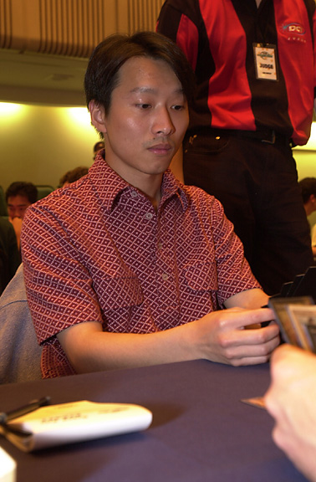
As tradition dictates, the Invitational was coupled with a Grand Prix in the host city. GP Sydney saw its American void filled by Dave Humphreys thanks to his all expense paid vacation courtesy of Chris Pikula. 'The Hump' barely missed Top 8 in a tournament won to the surprise of many by Gordon Lin's Replenish deck. Lin defeated William Coperman in the final, with Satoshi Nakamura finishing third.
With one weekend left in the month, there was barely time to squeeze in one more twin set of GPs, in Buenos Aires and Florence respectively. Both were attended by American pros, but it was in Buenos Aires where their presence without European colleagues was most noticeable. Alex Shvartsman, the OMS brothers, Dave Williams, James Stroud, Mike Pustilnick and Rob Nieves all made the trip, but in the end, the 'Americanos' failed to make the final cut, with an all Latin American top 8. In the final, it was Mexico's Hugo 'Ocho' Araiza emerging victorious with Replenish over Chile's Walter Witt, playing Sped Red.

Breakthrough performances of 2000: Trevor Blackwell, Chris Benafel, Noah Boeken, Black Ops, Aaron Forsythe
Florence, on the other hand, was a sea of Trix. Mox Diamonds, Necropotences and Illusions of Grandeurs were seen everywhere as an amazing 579 players Gathered to try their hand at extended. Benedict Klauser, who finished third at World Championships, walked away with the win, defeating Bram Snapvangers, playing Oath, in the final. Kai Budde, dormant for most of the year, finally broke out of his slump with a third place finish. It was a harbinger of things to come.

December
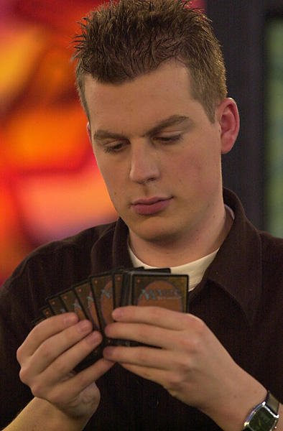
PT Chicago, the first individual PT of the season, was a landmark in that it was the first time since PT Dallas that T2 had been seen on a non-Worlds PT stop. With the recent introduction of Invasion to the format, a new environment with new decks lay in waiting. Many players complained that the occurrence of State Championships and Nordic Championships three weeks prior to the tournament essentially ruined the surprise factor, but one deck, Counter Rebel, which hadn't reared its head in those tourneys distinguished itself, especially in the hands of Kamiel Cornelissen, who in his first Top 8 made it all the way to the final.
Unfortunately for the young Dutchman, he proved no match for one of the top players in the game, Kai Budde. Becoming the third player in history to win 2 PT-level events, Budde, who had a horrible 1999-2000 season following his World Championship win in Tokyo, played a very consistent rebel deck, defeating Jay Elarar, Brian Kibler and Kornelissen in the top 8. Interestingly, it was Kibler who may have walked away the tournament's most memorable story, with his use of Rith, the Awakener and Armadillo Cloak making him the champion of 'kiddie decks' everywhere.
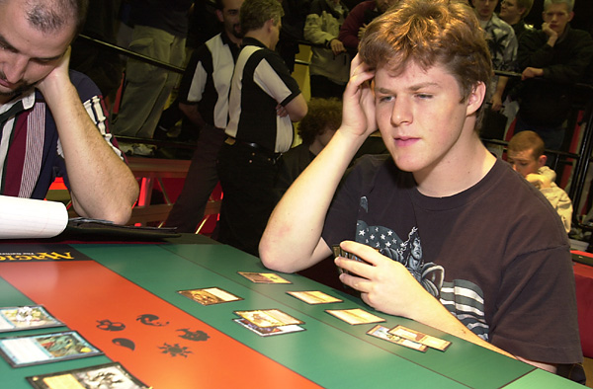
With Billy Jenson trying unsuccessfully to defend his Masters Crown, it was his teammate Ben Rubin who walked away with the big check this time around. Competing in an Invasion block limited single elimination tourney, Rubin, fresh off his loss to Jon Finkel in the finals of the Invitational gained more than a measure of revenge, defeating Finkeltron in their $10000 ante match. It was still an amazing weekend for Finkel, who finished second in the Masters and 5th in the Pro Tour. Andrew Cuneo and Jelger Weigersma both earned $2000 with each winning their respective half of the Gateway Tourney.
In the last premiere level event of 2000, Singapore's Sam Lau, not to be confused with the Canadian team member of the same name, walked away with $2400, beating countryman Jonathon Chan's Necro Strom deck. Lau, playing Oath, has had international success in the past, with a strong showing in the 1998 World Championships. Amongst the Americans who made the trip was Waiken Soo, who started US Nationals 2000 at 5-0 before being felled by Jon Finkel.
The year ended with one of its biggest stories. With WotC's number having grown astronomically and Pokémon sales coming back to earth, the feared Hasbro cutbacks became a reality. Fortunately, only two employees associated with Magic were released from their obligations, with one of them set to return as a contractor.

So there you have it. A mere 365 days, but a lot happened. I'd go into other stuff here and now, but after 5500-some odd words and research to boot, I'm beat. I hope you found this interesting and enjoyable and find the column worth reading. If you have any questions or comments, feel free to contact me at JGaryWise@yahoo.com. Have a good week

